**Regression Analysis: Impact of IMF Lending on GDP Growth**

-Poorab Panwar

**Introduction:**

**IMF:**

The International Monetary Fund (IMF) has an important function in lending financial support to nations with macroeconomic imbalances. Through its lending facilities, the IMF seeks to promote economic stability, increase investor confidence, and ensure sustainable growth. Nevertheless, the role of IMF lending in driving economic growth has been debated extensively among scholars and policy analysts.

**About this project:**

The purpose of this project is to empirically determine if there is a significant effect of IMF lending on the economic growth of recipient nations. The analysis of a specially constructed dataset with 224 observations spanning many countries and years examines how GDP growth is related to three primary explanation variables: the Amount Drawn from the IMF, Inflation Change, and Debt Change. This entire dataset has been created by me from scratch by researching websites like IMF, world bank. A few datapoints were missing from the original sources and were replaced by ai estimates for the purpose of completeness.

**About the dataset:**

This dataset includes 223 rows and 17 columns including countries, lending data, inflation(gdp deflator %), Gdp , Public debt in %. The data has been further cleaned and modified during the analysis.

**Regression model and Data analysis:**

Residuals:

|  |  |  |  |  |
| --- | --- | --- | --- | --- |
| Min | 1Q | Median | 3Q | Max |
| -0.58157 | -0.07849 | -0.02445 | 0.05551 | 0.60432 |

|  |  |  |  |  |
| --- | --- | --- | --- | --- |
| Variable | Estimate | Std. Error | t value | Pr(>|t|) |
| Intercept | 1.535e-01 | 1.149e-02 | 13.360 | <2e-16 |
| Amount Drawn | -5.50e-09 | 2.849e-09 | -1.93 | 0.0549 |
| Inflation Change | 0.006065 | 0.003026 | 2.005 | 0.0462 |
| Debt Change | 0.004517 | 0.009077 | 0.498 | 0.6192 |

Residual standard error: 0.1545 on 219 degrees of freedom

Multiple R-squared: 0.03672, Adjusted R-squared: 0.02353

F-statistic: 2.783 on 3 and 219 DF, p-value: 0.04182

**Interpretation:**

The regression is run on the following:

The general form of a multiple linear regression equation is:

y = α + β₁x₁ + β₂x₂ + β₃x₃.

Gdp_Growth ~ α +Amount.Drawn + Inflation_change + Debt_change,

Where Gdp Growth = Y, Bx1 = Amount Drawn, Bx2 = Inflation changes, Bx3 =Debt change.

***Intercept***: Baseline GDP growth when all independent variables are zero is 15%

***Amount Drawn:*** Marginally significant at 10%. Suggests a small negative relationship between the amount of IMF funds drawn and GDP growth.

|  |
| --- |
| ***Inflation Change***: Statistically significant at 5%. A **positive relationship**, indicating that higher inflation changes (possibly demand-driven) are slightly associated with higher GDP growth.  ***Debt Change***: Not statistically significant. No conclusive relationship between debt changes and GDP growth.  ***Residuals:***   * Range from -0.58 to +0.60 * Symmetrical distribution around the median * Indicates reasonable model balance but relatively high variation.   ***Multicollinearity:***   * Amount Drawn = 1.003979 * Inflation change = 1.003979 * Debt change = 1.003467   Variance Inflation Factors (VIFs) for all variables are close to 1. Hence no multicollinearity. |

**Data Visualisation:**

|  |
| --- |
|  |

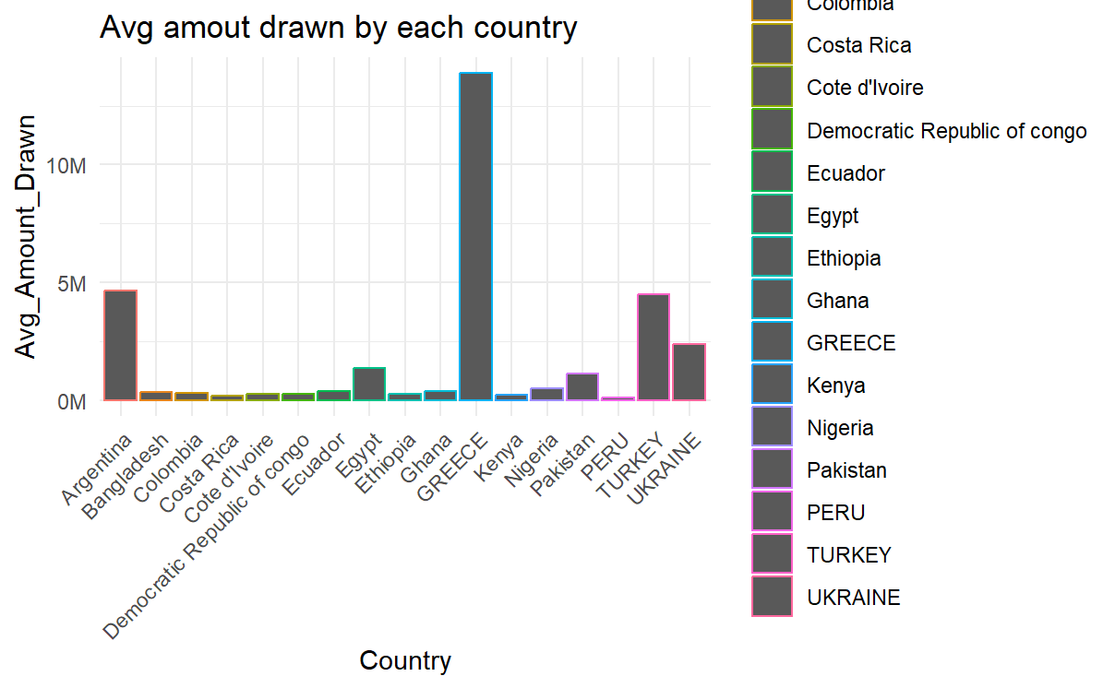

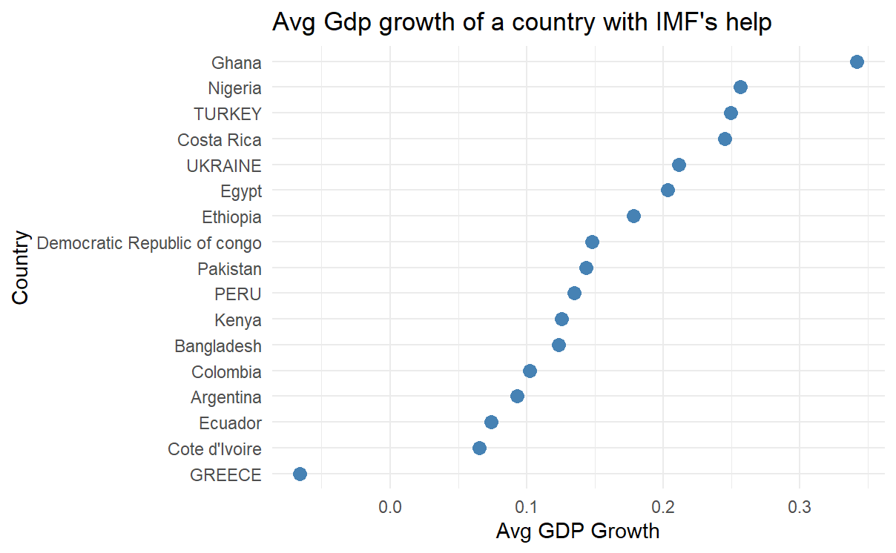

The above graph shows the average gdp growth rate of each countries. The Graph showing the average amount drawn by the Countries shows Greece as the highest average amount drawn, but the gdp growth rate seems very less. Whereas Ghana, who borrowed less, had highest growth rate.

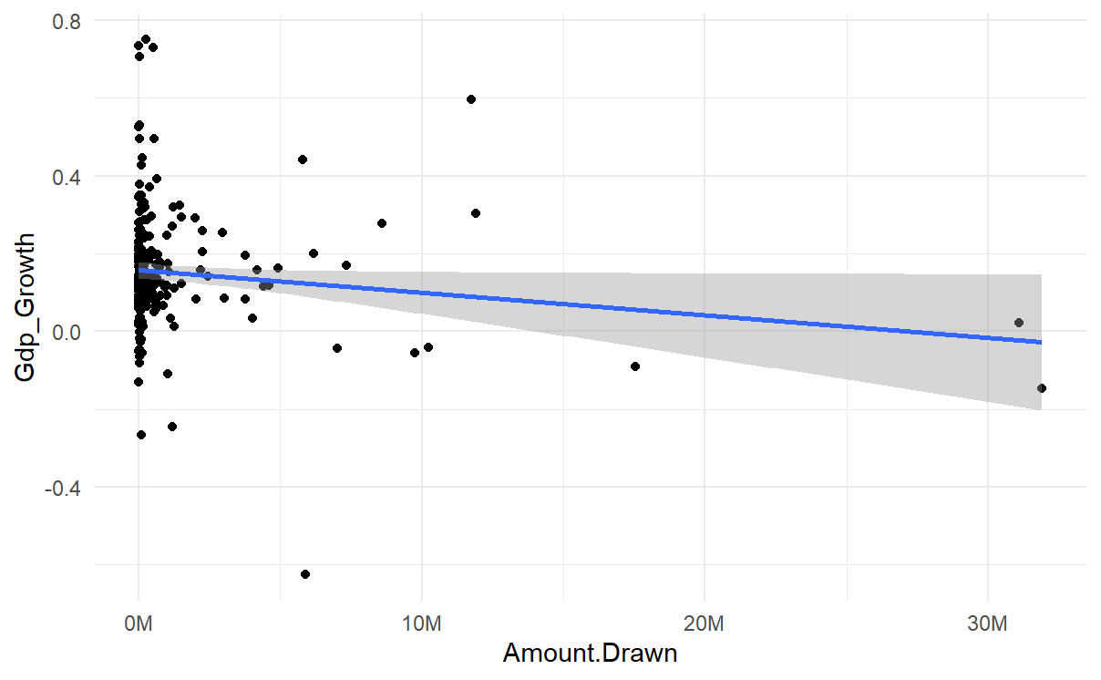

The graph above offers an empirical look at a specific economic relationship between Gdp growth and amount drawn by the countries. The regression line has a slightly negative slope. This suggests that, on average, as the Amount Drawn increases, the GDP Growth tends to decrease slightly. The graph above shows that the points on the plot deviate from the line of best fit. The deviation of the independent variable "Amount drawn" and the dependent variable "gdp growth" indicates that there is a lot of variability in GDP Growth for any given Amount Drawn. Due to the large scatter, the Amount Drawn is likely not a strong predictor of GDP Growth when considering all instances together. There are many other factors influencing GDP Growth that are not captured in this simple two-variable relationship.

**CONCLUSION:**

The findings of this analysis are that IMF lending could have no very direct impact on GDP growth at least in the purview of this dataset and model. Amount Drawn from the IMF has an extremely weak and only marginally significant negative correlation with GDP growth. This could be a reflection of the fact that nations which are taking more from the IMF tend to be in economic distress already, which could dampen growth regardless of IMF support. Conversely, Inflation Change seems to have a statistically significant positive influence, perhaps reflecting short-run economic activity spurts in inflationary contexts. Debt Change had no significant relationship with GDP growth. Although the model is faulty, e.g., low explanatory power (R²).

This study shows a careful use of econometric methods to consider a concrete policy question: "Does IMF lending cause economic growth?" Tentative results notwithstanding, the process is a rigorous data-driven approach to applied economics.